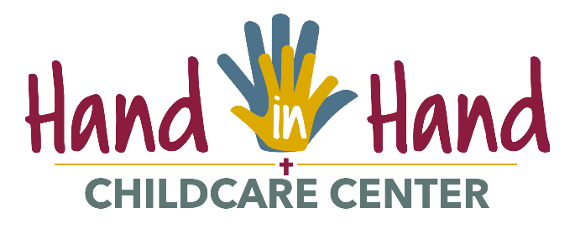

2024-2025 CALENDAR

SEPTEMBER 2024
Service Project – Welcome to New Student Residents on Move-in Day
Monday, September 2 Center closed – Labor Day Regular tuition applied

OCTOBER 2024
Tuesday, October 15 Field Trip to Afton Apple Orchard
Friday, October 18 Picture Day
Thursday, October 31 Halloween Party

NOVEMBER 2024
Service Project – Food Drive for Concordia Food Shelf
Tuesday, October 19 Toddler and Preschool Parent/Teacher Conferences
Tuesday, October 26 Toddler and Preschool Parent/Teacher Conferences
Thursday, November 21 Family Night
Thursday, November 28 Center closed- Thanksgiving Regular tuition applies
Friday, November 29 Center closed- Thanksgiving break Regular tuition applies

DECEMBER 2024
Service Project – Toy Drive/ Mitten Tree
Friday, December 20 Christmas Party – 9:30-10:30
Monday, December 23 – Friday, December 27 Center closed – Christmas Break No tuition due
Monday, December 30 – Wednesday, January 1 Center closed – Christmas Break Regular tuition due

JANUARY 2025
Monday, January 20 Center closed – Martin Luther King Jr. Day Regular tuition applies
Friday, January 31 Beach Party

FEBRUARY 2025
Service Project – Staff Service Project
Friday, February 14 Valentines Day and Pajama Party
Monday, February 17 Center closed – President’s Day Regular tuition applies
Teachers report for In-service
Friday, February 28 Center closed – Early Childhood Educators Regular tuition applies
Conference

MARCH 2025
Tuesday, March 4 Toddler Parent/Teacher Conferences
Wednesday, March 5 Preschool Parent/Teacher Conferences

APRIL 2025
Service Project - Student Employee, Staff and Parent Appreciation
April 7-11 Week Of The Young Child events
Thursday, April 10 Spring Family Night
Friday, April 18 Center closed – Good Friday Regular tuition applies

MAY 2025
Service Project – Service Staff Appreciation
Friday, May 2 Center closed – Staff In-service Regular tuition applies
Friday, May 9 Muffins with Moms - 9:30-10:30
Monday, May 26 Center closed – Memorial Day Regular tuition applies
TBA Spring Field Trip - TBA

JUNE 2025
Friday, June 13 Donuts with Dads - 9:30-10:30
Wednesday, June 19 Center closed – Juneteenth Regular tuition applies

JULY 2025
Friday, July 4 Center closed - Independence Day Regular tuition applies

AUGUST 2025
Thursday, August 7 Center closed – Teacher In-service day Regular tuition applies
Friday, August 8 Center closed – Teacher In-service day Regular tuition applies
TBA Family Picnic – 5:30-7:30

